Press release from Jo Allison
lhdobkins@gmail.com
540-239-6221
joallisonauthor.com
oldunderwoodpublish.com

New Series Uses 1910s St. Louis as Backdrop for Young Female Sleuth

Bristol, VA, June 14, 2016 A new mystery series that begins in 1910 St. Louis uses the issues of the early twentieth century to highlight a young “new woman’s” fight for justice.
A new woman, in early twentieth century parlance, is one who supports progressive causes, including suffrage, who likely works outside the home, and who challenges the restrictions of the women’s sphere of activities.
Julia Nye’s unconventional position as a typist for the St. Louis City Police Department in 1910 gives her opportunity to engage in the detective work she learned to love with her sheriff father. It also means opportunity, along with danger, for her two male news reporter friends. In fact, it’s hard to believe how much danger a typist can find in crimes that reflect the issues of the day: prohibition (yes, there were dry states and counties well before 1920,) race relations through the lens of ragtime, sexual slavery, labor unrest, and more. As dangerous as the detection is, Julia finds the emotional, social, and romantic demands of new-woman-hood just as challenging.
St. Louis, the fourth largest city in the U.S. in 1910, is a player in many of the issues.
While each books features a dangerous puzzle for Julia and her friends, the overarching theme of the series has to do with Julia’s continual fight for respect. The situations she faces challenge her along those lines, of course.
“When I started the series,” author Jo Allison says, “I wasn’t writing to a theme. Julia taught me the important points as I wrote. At first I worried that modern readers wouldn’t understand an edgy woman’s plight in 1910, but I’ve realized the dilemmas are still with us. It’s taking a whole series for that to unfold.”
The first two books in the series, The Good Old Summertime and St. Louie Slow Drag are available on Amazon as paperbacks and as ebooks. The first book begins with the suspicion that a lawman who dislikes prohibition would stoop to breaking the law and ends with the dangerous passions that prohibition ignites. In the second book, after Julia and her friends thwart the racists who are try to burn the Mill Creek Valley in St. Louis, disappointed religious fanatics decide to finish the job—with Julia’s murder to be the spark for riot and destruction.
The third book, Heaven Will Protect the Working Girl, which sees Julia go undercover to nab what was called a “white slaver,” is due out in August 2016. The fourth book, Bread and Roses, deals with women union activists and labor unrest. It is set for release in early 2017.
Jo Allison is the award-winning author of the Julia Nye mystery series and related short stories. The Greater St. Louis Area Sisters in Crime chapter has highlighted her first two novels. Her short story that is the immediate prequel to the Julia Nye series took first place in the Virginia Writers Club Summer Shorts contest for 2015. Allison’s website, joallisonauthor.com, has that short story and others that take place between events in the novels.
Allison also maintains a website for students/scholars/anyone interested in the early twentieth century. 1910-stlouis-by-jallison.com offers the research on some fourteen topics that lay the foundation for the novels. Topics include music, medicine, fashion, transportation, baseball, etymology, race, environmental issues, and “being twenty-something in 1910.”
Readers who like to solve murder mysteries in an historical setting and who like to do so through the eyes of historically appealing characters should look for the Julia Nye Mystery Series by Jo Allison under Books at Amazon.com.

Contact information:

Allison is an indie author who uses Old Underwood Publishing Company to produce her series. More details can be found at oldunderwoodpublish.com. Review copies of the books are available by contacting Allison at lhdobkins@gmail.com (Jo Allison is the pen name of Linda Harris Dobkins. See joallisonauthor.com.)

Author Bios for Jo Allison

Short Short bio (129 characters with spaces)

Jo Allison’s Julia Nye Mysteries, set in 1910s St. Louis, highlight a bold heroine fighting the issues and prejudices of the day.

Short author bio (60-word)

Jo Allison writes the Julia Nye Mystery series, which is set in 1910s St. Louis. Allison drives family and librarians crazy with the depth of her research on the city and on the time period but delights readers who like their mysteries historical. She maintains a web page that highlights the setting at 1910-stlouis-by-jallison.com. Series-related short stories are at joallisonauthor.com.

Medium length author bio (100-word)

Jo Allison writes the Julia Nye Mystery series, set in 1910s St. Louis. Allison drives family and librarians crazy with the depth of her research on the city and on the time period, but delights readers who like their mysteries historical. In addition to turning out the series, Allison maintains a website dedicated to the micro-history of both 1910 and St. Louis, 1910-stouis-by-jallison.com. Topics range from what people wore to how they got around to the issues that they talked about. Allison also writes short stories and vignettes that support the novels—“between murders”—and those are available on joallisonauthor.com.

Enough-already bio (164 [187]-word)

Jo Allison is the award-winning author of the Julia Nye Mystery Series and related short stories. Her short short story (1200 words) that is the immediate prequel to the Julia Nye series took first place in the Virginia Writers Club Summer Shorts contest for 2015. See Allison’s website, joallisonauthor.com, for that short story and others that take place in between events in the novels.

The Greater St. Louis Area Sisters in Crime chapter in 2015 highlighted the first two books in the series, The Good Old Summertime and St. Louie Slow Drag. Two pieces of Allison’s academic work, under her scholarly name, Linda Harris Dobkins, deal with women and suffrage in St. Louis. The second of those pieces won the Neth Award for 2014-15 from the State Historical Society of Missouri.

Having amassed a good deal of history about the era and the city, Jo Allison maintains a website detailing what life was like in St. Louis in 1910. [Topics include dress, transportation, St. Louis neighborhoods, the music scene, the vocabulary of the day, Black American issues, prohibition and suffrage—and more.] Check it out at 1910-stlouis-by-jallison.com.

For more information, see joallisonauthor.com, 1910-stlouis-by-allison.com, and oldunderwoodpublish.com.

Because you’re busy . . . Interview Questions

- Other than being set in 1910s St. Louis, what is the series about? (I can answer this without the elevator.)
- O.K. Why 1910 and why St. Louis?
- You say the books are built on the situations of the day. Like what?
- I thought prohibition didn’t start until 1920. What is your research process?
- You have three books in the series coming out in a span of five months. Is that fast writing or what? (Those three books sat in an electronic drawer for more than ten years.)
- Is there a fourth?
- Do your books have a theme?

And others you wouldn’t know to ask . . . Five Things You Don’t Know About Me from Bios and Websites (unless you read really carefully.)

- I love baseball and once talked my way into teaching a course on baseball for college students—as a way for them to improve learning skills.
- My favorite outdoor activity is kayaking on mountain lakes—and streams if they promise not to move too fast.
- I love craftsman/prairie/mission design. After driving all over St. Louis to find the right bungalow for my characters, I laid out its interior to resemble my grandparents’ house—which I was in once, long after they were dead and the house had become an antiques store.
- Two of my three main, continuing characters are reporters, which was my original career. When I began working in television news at age 20, I was the first woman in my hometown to do so. And I wrote on a typewriter (will explain on demand) that wouldn’t have been radically different from what my characters use in 1910.
- Once upon a time, I loved to play ragtime. (My skills have deteriorated alarmingly.) That’s why I used ragtime as a vehicle to look at 1910 race relations in St. Louie Slow Drag. A slow drag is a kind of rag tune.

Synopses of Books in the Julia Nye Mystery Series – in differing lengths

The Good Old Summertime Book One

A. In 1910, Julia Nye insists on investigating the death of a country sheriff from her unconventional position with the St. Louis Police Department. Her investigation uncovers the passions that fuel the prohibition debate and spread back into the city to endanger Julia and her friends.

B. When the Sheriff of Ste. Genevieve County, Missouri, dies in a wagon accident, Julia Nye is determined to investigate. From her nominal position as a typist in the City of St. Louis Police Department, she is sure of only a few issues surrounding the Sheriff’s death: that lawmen don’t break laws, even those they dislike; that prohibition is a passionate issue but not one worth killing for; and that the investigation itself is certainly not a deadly undertaking. She recruits two male reporter friends and the trio finds out, each person in a different way, that those sureties may not hold.

C. In 1910, Julia Nye has an unconventional job as a typist for the St. Louis City Police, a first for a woman but not as unconventional as her desire to be a detective like her sheriff father. When her father’s friend, the sheriff in Ste. Genevieve County, dies in a suspicious wagon accident, Julia is excited about the opportunity to investigate along with two male reporter friends.

But it turns out the sheriff’s death involves bootlegging. And in 1910, the countryside is a patchwork of dry localities and wet localities, with passions on both sides of the prohibition question threatening the peace. In Ste. Genevieve and back in St. Louis, police detectives and even Julia’s suffragist housemates make the investigation complicated—and deadly.

As she sees her two friends increasingly in danger, Julia worries that her urge to investigate is the cause of the continuing violence. Finding herself unexpectedly attracted to one of the men makes the situation more worrisome than she could have imagined. Julia has to decide. She can take the advice of almost everyone to lay low and let the prohibition passions ebb. Or she can struggle to expose a surprise enemy and push the investigation to a dangerous finish.

St. Louie Slow Drag Book Two

A. In the steamy August of 1910, St Louis is rocked by murders and arsons in its ragtime district. Julia Nye, a young “new woman,”and her two male reporter friends have to face down the racists who are trying to burn the neighborhood as well as the religious fanatics who think Julia’s murder could be the spark for riot and destruction.

B. In the steamy August of 1910, St. Louis is rocked by murders and arsons in a neighborhood home to Negroes, brothels and ragtime. (The slow drag is a ragtime style.) The tensions threaten the friendships among a trio of quasi-amateur sleuths: Julia Nye, suffragist and typist at police headquarters, and reporters William McConnell and Carl Schroeder. After the trio pulls together to thwart the racists who try to burn the neighborhood, disappointed religious fanatics decide to finish the job, with Julia’s murder to be the spark for riot and destruction.

C. In 1910, Julia Nye has an unconventional position as a typist for the St. Louis City Police. And one steamy August evening, she goes on an unconventional date, to hear ragtime masters in St. Louis’s seedy, prostitution-laced Mill Creek Valley. When the rag club erupts in flames and a Negro musician is found dead in the alley, Julia realizes she can make a contribution to solving the crimes. The authorities are unlikely to find out anything from the young Negro woman Julia has befriended.

Meanwhile, the Chief of Police wants Julia to use her other skill—with a rifle—to tame a riot situation. His demands may mean a loss of what Julia holds dear, her suffrage activities and her romance. What she doesn’t see coming is that her involvement has put her in someone else’s cross-hairs: she has become the woman whose death could spark the riot.

Heaven Will Protect the Working Girl Book Three

A. In 1910, Julia Nye’s unconventional position with the St. Louis police department becomes even more unconventional as she goes undercover to incriminate a sexual slavery dealer suspected of murder.

B. In 1910, Chicago is trying to rid itself of the white slave trade, and the deaths of two factory girls in St. Louis brothels signal that the vice has shifted to St. Louis in the person of a slick factory owner. Our three sleuths respond: suffragist Julia Nye usually types for the St. Louis police, but now agrees to go undercover in the factory; reporters William McConnell and Carl Schroeder head to Chicago to uncover the man’s background. What William and Carl discover convince them to get Julia out of the factory at the same time that Julia overhears her new boss plan to end the men’s investigations by making sure they don’t return to St. Louis. The threats all around send Julia down the same path as the women she’s trying to avenge.

C. In 1910, Julia Nye’s job is supposed to be typing for the St. Louis Police Department. But, when two factory workers die after being confined in brothels, the police realize that a slaver may have moved from Chicago to St. Louis to escape a sweep of the sex trade in the Windy City. And the most effective way to uncover the operation is to ask Julia to work in a shirtwaist factory. And watch.

Working in the factory—and living with two police officers who are working the ruse as well—will strain Julia’s relationship with her beau, a news reporter for a major St. Louis daily. William McConnell leaves for Chicago to investigate the factory owner’s background and to rethink his difficult relationship with Julia. Fellow reporter Carl Schroeder follows, and the two discover more than background. They stir up danger for both William and Julia. Assassins and the slaver’s interest in his new employee lead William and Julia to fight not only for their relationship, but also for their lives.

A Micro-History Contribution

In fifteen years of doing research on both the 1910s time period and the city of St. Louis, Jo Allison has accumulated a significant micro-history, a study of the day to day life of residents of the nation’s fourth largest city in 1910. That information is available on her website 1910-stlouis-by-jallison.com.

The research behind this information is provided in general terms. There is even a section on how to do research on the city and the time period.

The topics explored on the website are:

being twenty-something in 1910
music in 1910
so, what happened in 1910 if you got a booboo or worse?
getting around in 1910
what to wear in 1910
current events of 1910-11
can i say that in 1910? (etymology)
baseball & beer
the environment of a dirty city
st. louis women
black americans in st. louis
what neighborhood are you from?
prohibition, suffrage—and iced tea
researching 1910 st. louis

Jo Allison is also the author (under her academic name, Linda Harris Dobkins) of two articles that deal with St. Louis women and their efforts to achieve and use the suffrage.
The first article, “Politics, Economic Provisioning, and Suffrage in St. Louis: What Women Said, What Men Heard,” was published in the American Journal of Economics and Sociology, Vol. 71, no. 1, January 2012. It deals with the conditions that led to passage of woman suffrage.
The second article,"What Men Expected, What Women Did: the Political Economy of Suffrage in St. Louis, 1920-1928," Missouri Historical Review, Vol. 109, no. 1, October 2014, is an investigation of what St. Louis women did with the vote when they got it. (Interesting story: the early St. Louis League of Women Voters was not content to get voters to the polls. They organized a campaign to defeat two judges of the Courthouse Ring; they promoted candidacies of women to the school board; they fought against politicians who had opposed the suffrage vote. Then they were told by the national League to cool it, to avoid making political enemies, and settle for get out the vote campaigns.) This article earned the Mary C. Neth award for best article dealing with gender history from the State Historical Society of Missouri in 2015.

A sample chapter for each of the books . . .

The Good Old Summertime

Chapter one

From the St. Louis Globe-Democrat, Tuesday, June 4, 1910
Opponents of prohibition are charging that some Anti-Saloon League members actually hope the amendment prohibiting liquor statewide will fail in the November vote.
The charge says that members of the League benefit from getting paid in the campaigns to convert counties to no-license jurisdictions one by one. More than half the state’s counties and towns currently prohibit the sale and use of alcohol.
Sheriff Claude Picard lit himself a cigar, got comfortable on the fresh grass of early summer, and studied the creek that used to be the Mississippi River.
The shallow water still marked the boundary between Missouri and Illinois. But these days it wandered through the rocks of the wide, steep-sided bed that had been forsaken by the big river. The Mississippi flowed several miles to the east.
Every time he came here, Claude thought about the flood of ‘81, most of thirty years ago now, when the Mississippi River covered the town of Kaskaskia, Illinois. He knew an old-timer who claimed he’d gone out in a rowboat and could see the chimneys of the town below. Everyone had waited for the river to return to the state line, but it had receded to its new path and was still there, where it might swirl over the old settlement forever. The narrow bridge in front of him, spanning high over the creek, was the only way off what was now an Illinois island with a handful of residents. Tragedy at the time, but it suited his present needs right well.
Claude contrived to arrive ahead of Ettie on the nights they met, watching for her wagon’s cautious approach over the bridge onto the island. Two-foot-wide board tracks lay over the crosspieces, and Ettie always hit them straight on. This evening, he had watched her leave the same careful way, watched her turn precisely onto St. Mary’s Road, watched the wagon and its cargo disappear. As usual, he was biding a while after she left. Didn’t want to offend the sensibilities of any stray traveler going her way into Perry County, no more than two miles down the road.
It had been an easy meeting tonight, but the sensibilities between him and his two old police buddies were another matter. John in particular. Claude had made it clear to John Nye that he wasn’t about to quit the trade, and if John and Micah saw fit to be offended, so be it.
Nonetheless, the memory of John’s reproach during his visit at the jail last week, complete with the hasty retreat of Claude’s two young deputies who had sauntered in at the worst moment, made this evening less pleasant. Claude realized he’d bit down on the cigar sufficient to taste tobacco. Fine. He was ready to get home, and Ettie should be far enough down the road. He squashed the lit end of the disfigured cigar on the ground and strode back to the wagon.
“None of their business, anyway,” he said out loud.
Neddie, the Belgian on the right, shook his head and whinnied—in agreement, Claude supposed.
“You’re right, old boy. Let’s get on home.” Claude tucked the money belt under his right thigh and snapped the reins. The horses moved out smartly, and he knew the empty wagon was no more than a featherweight to the big draft animals. By the time the team approached the bridge, Claude had them trotting like buggy horses.
They took the leading edge of the tracks with ease, and Claude braced himself for the bump when the wagon’s wheels hit.
There was a bump, O.K., and a loud crack. The left front of the wagon seemed to sag. Claude looked over the side to see the metal rim leaving the front wheel to travel off on its own.
The spokes cracked in turn, sounding for all the world like a Gatling gun was mounted under the wagon. The horses bolted, and the combination of the lost wheel and even more speed made the wagon skid to the right. Toward the edge of the board tracks.
Through the almighty noise, Claude heard a thud, the money belt hitting the floorboard. Cursing, he lunged to his right for the damn thing. He got hold of the buckle just as the strangest vision took his attention, Marjorie screaming, “Let it go!”
His wife’s image was still before him when the wagon slammed into the low railing.
Claude grabbed for the top rail, but his momentum ripped it from his grasp. All he had in hand was the money belt as he went headlong over the edge. One moment he was thinking that, all in all, it would have been a might softer landing to fall into the Mississippi. The next, he was hearing his last curse turn into a scream.

St. Louie Slow Drag

Chapter one

From the St. Louis Globe-Democrat, Saturday, August 17, 1910
Friends of ragtime pianist Scott Joplin have confirmed that the composer of the “Maple Leaf Rag” and other popular piano pieces is visiting this week. Joplin moved from St. Louis to New York City several years ago in order to pursue his career there.
Joplin will be appearing and performing in support of the candidacy of Charles Turpin, a negro, who is standing for election to Constable in the Fourth District.
The music popped and jiggled and jumped from the piano keys, rattling my bones and vibrating in my gut. It demanded that I move and that I grin. So far, I’d resisted both.
Ragtime is decadent. People said so, often from the pulpit, repeated in parlors. I’d heard rags before, but never like this. The Aurora Club was the genuine article, dead in the heart of St. Louis’s red-light district, in a colored neighborhood I’d been warned to avoid. I would never in a hundred years have chosen to come here except William McConnell had invited me to meet visiting ragtime master Scott Joplin.
Truth be told, William pushed the limits of social convention to suggest a date at the Aurora Club. I pushed the limits to take him up on it. And, I must admit that I liked the pushing part.
“The Aurora is a music club,” William had said. “There’s a sporting house next door, but the Aurora only offers food, beer, and music. Will you be comfortable with that, Julia?”
I had only let one small doubt show. “William, are you sure I’ll be welcome . . . there?”
William had taken a moment for his characteristic smile, closed lips pushing into deep vertical dimples. “You’ll be there with me.”
It might have been bravado on his part, but sure enough, Scott Joplin had greeted William like an old acquaintance in spite of what I thought was the man’s natural reserve. And added, “So nice to meet you, Miss Nye.” The huge negro virtuoso Tom Turpin bellowed, “Hopin’ you’d come, Mac,” before seeing me over William’s shoulder and breaking into a frown. Would-be constable Charlie Turpin welcomed us—even if I couldn’t vote for him—and distracted me from his brother’s irritation at my presence.
So, William knew these folks, enjoyed real friendships here. The idea that he was more at home than I in an unconventional situation might be part of what bothered me.
In fact, the night and the Aurora Club unnerved me. A stage rose along the wall to our right, a foot or so above floor level to highlight the ornate upright piano. Above it, the painting of a barely dressed lady suggested what was happening in the sporting house next door. The bar at the back stretched across half the width of the room. I’d not seen enough bars to know for sure, but I fancied it less grand than some, more grand than most. Its brass parts sparkled, and its wood parts shone. Through the opening behind it, a kitchen offered up the grease and greens I could smell. Just now, men lined the bar, commenting on us as well as the music, I imagined. In defense of my nerves, William hadn’t mentioned that we’d be the only white folks in the room.
On top of all that, I was sweaty. Dewy, my mother would have said. I’d looped my thick chestnut braid into a chignon, but moisture crept up my nape. Other people were dewy, too. Beyond the tang of cheap perfume and cheaper tobacco, the room smelled of the seventy-five or eighty people crammed into a space that should’ve held fifty, on a close August night.
As Joplin took the applause from a number, William leaned close and asked, “Are you O.K, Julia?”
I raised an eyebrow to imply I didn’t require his concern. I’m not sure he believed me, but he raised an eyebrow in response and withdrew.
I stopped my head from bobbing in rhythm to what Joplin called a “slow drag.” I just wasn’t comfortable enough to lose myself in the music. For distraction, I decided to follow the progress of a petite woman searching the crowd—with difficulty. She avoided looking anyone in the eye or even brushing against anyone. The only thing I could conclude was that her conventional dress made her less comfortable in the heat than necessary. I had at least two less petticoats, one less corset, and absolutely no lace at my throat.
Plus, William and I were near the front door, behind the crowd and near a source of moving air. William called it his “reporter spot,” easy for counting the crowd and making a quick get-away, not that he should need to do either on a date.
I lost sight of the young woman between pieces when Tom Turpin moved to the piano. He twisted the poor piano stool several notches lower, sat, and raised enormous hands. I’d thought when I was introduced to him that each finger was too wide for the slices of ivory. Now the big hands assaulted the keys.
Turpin swung into the “Maple Leaf Rag,” the one ragtime tune I recognized by name. His was not the parlor version I was used to. He transformed the piano into a small band that thumped and blew and plucked under the ragged melody. I had felt the martial stir from parade bands. I had swayed to the one-two-three of popular ballads. But Turpin’s rag was the most exciting piece of music I’d ever heard. I gave in, dismissed the young negro woman, and commenced foot-tapping, bobbing, and grinning. William grinned as well, delighted in my capitulation.
Loud as the crowd was with its whistles and stomping, the blast that issued from the kitchen silenced us all for a scant second. I was trying to sort out what had happened when William pushed me toward the door, saying, “Out! Now!”
I didn’t hesitate, but I did glance back at the loud whoosh that meant gas had ignited. The back wall of the kitchen looked like the globe of an oversized kerosene lamp, the flame turned way too high. It backlit screaming patrons.
William called, “Keep moving!” as if I had a choice. Not all the hands on my back could be his.
The blast must have ruptured and ignited a gas line out front as well, because I caught a glimpse of fire just outside the front door to the right. William pulled at my arm and moved around me. He was first through the opening, and my surprise at his behavior was lost in the odd impression that he was shouting, “Stop!” to the flames beyond the doorframe.

Speaker Availability

Jo Allison is available for speaking events.

She offers programs on
- writing historical fiction in general,
- the 1910 era, particularly in St. Louis,
- and weaving historic events into fiction.

Allison has background both in mystery fiction writing and in academic writing. (For that matter, she also speaks on the state of the US economy. She holds a PhD in economics.) Her last two academic publications were in the field of economic history and involve the work of St. Louis women in getting and using the vote. The two articles together cover the period from 1916 to 1928.
The first article, “Politics, Economic Provisioning, and Suffrage in St. Louis: What Women Said, What Men Heard,” was published in the American Journal of Economics and Sociology, Vol. 71, no. 1, January 2012. It deals with the conditions that led to passage of woman suffrage. The second article,"What Men Expected, What Women Did: the Political Economy of Suffrage in St. Louis, 1920-1928," Missouri Historical Review, Vol. 109, no. 1, October 2014, is an investigation of what St. Louis women did with the vote when they got it.

Images
See online version of press kit to retrieve images electronically.

Author image from website
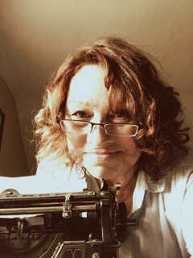
Cover of The Good Old Summertime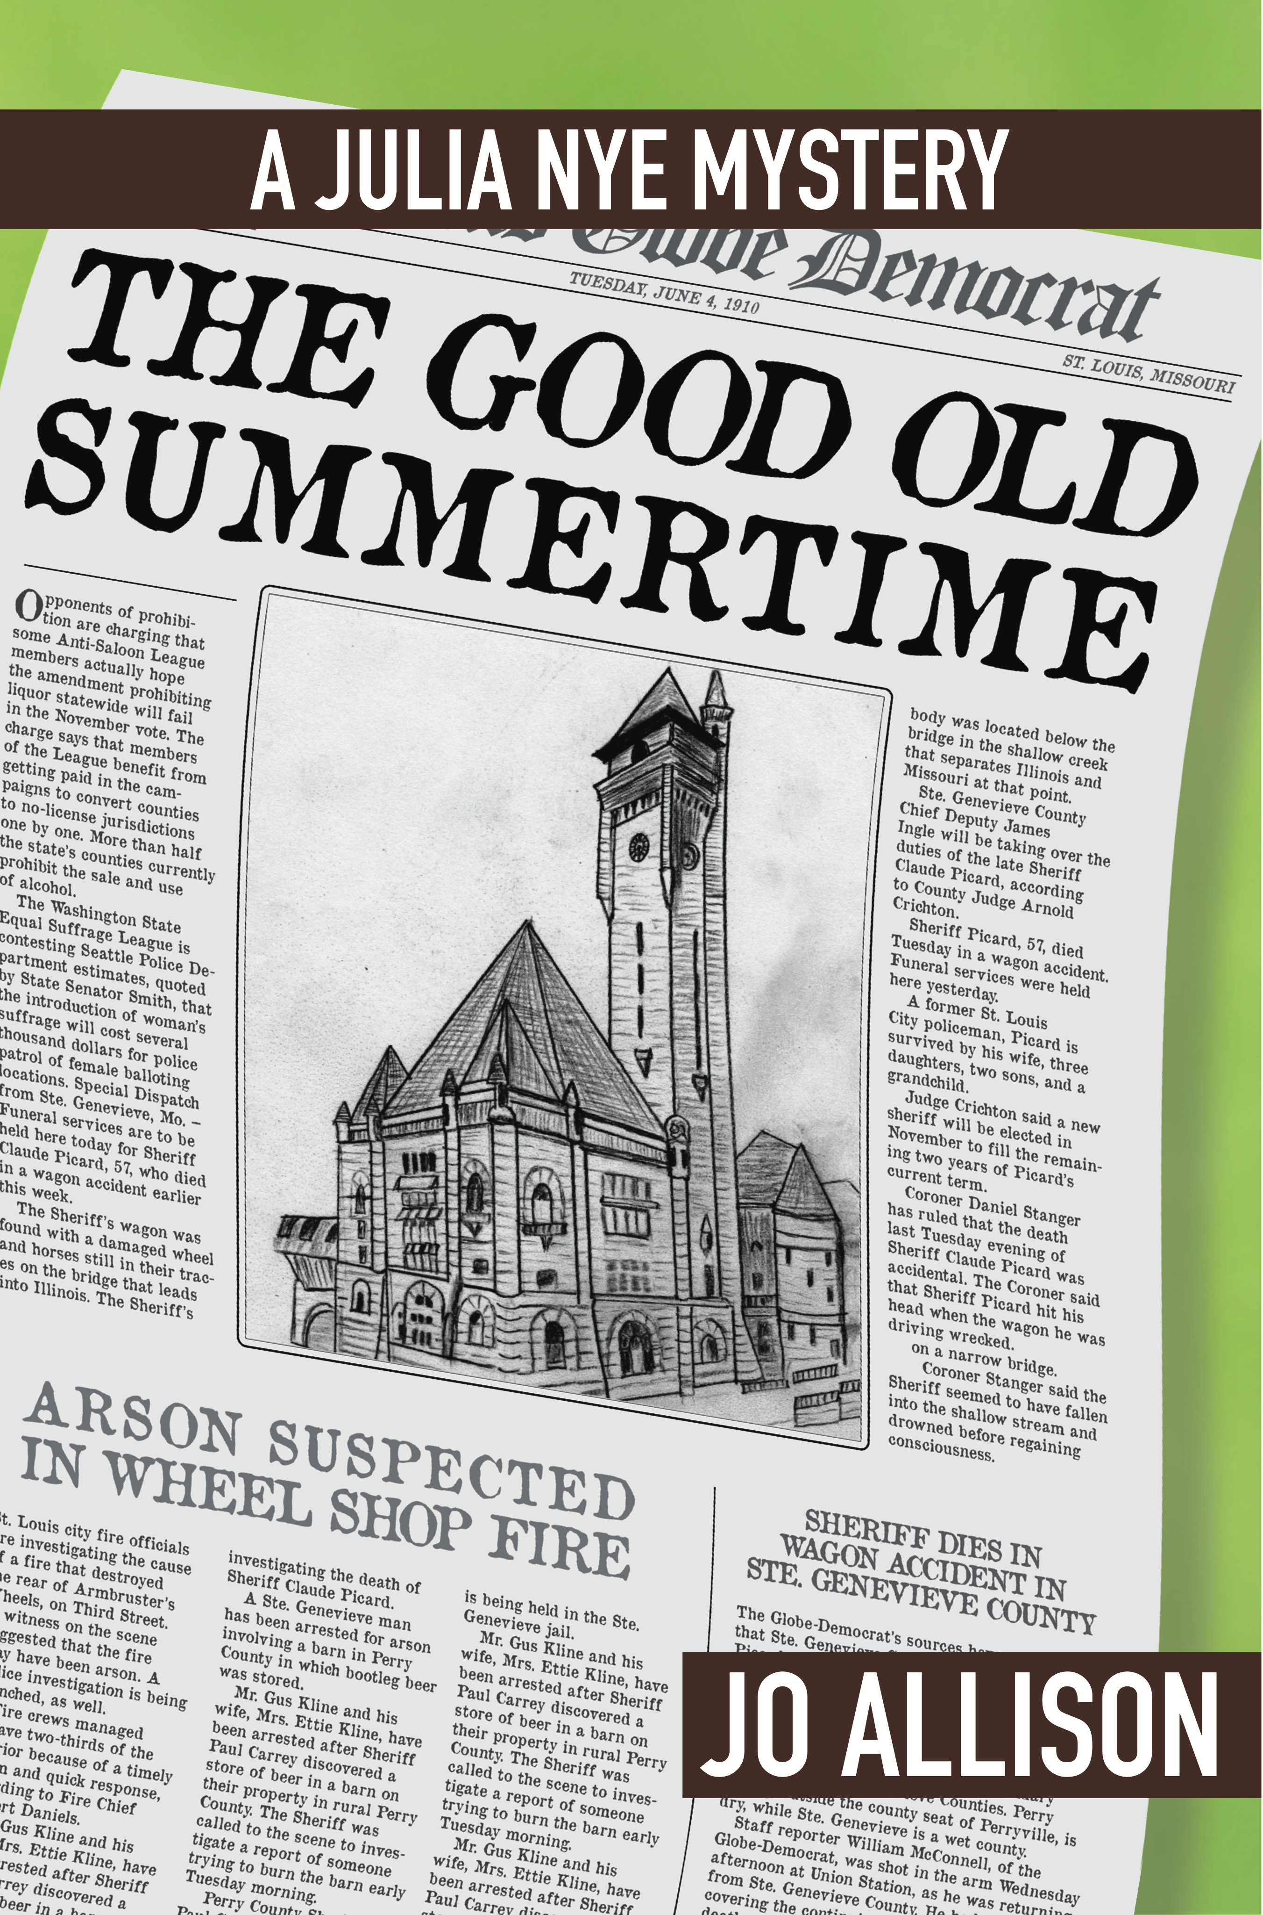
Cover for St. Louie Slow Drag 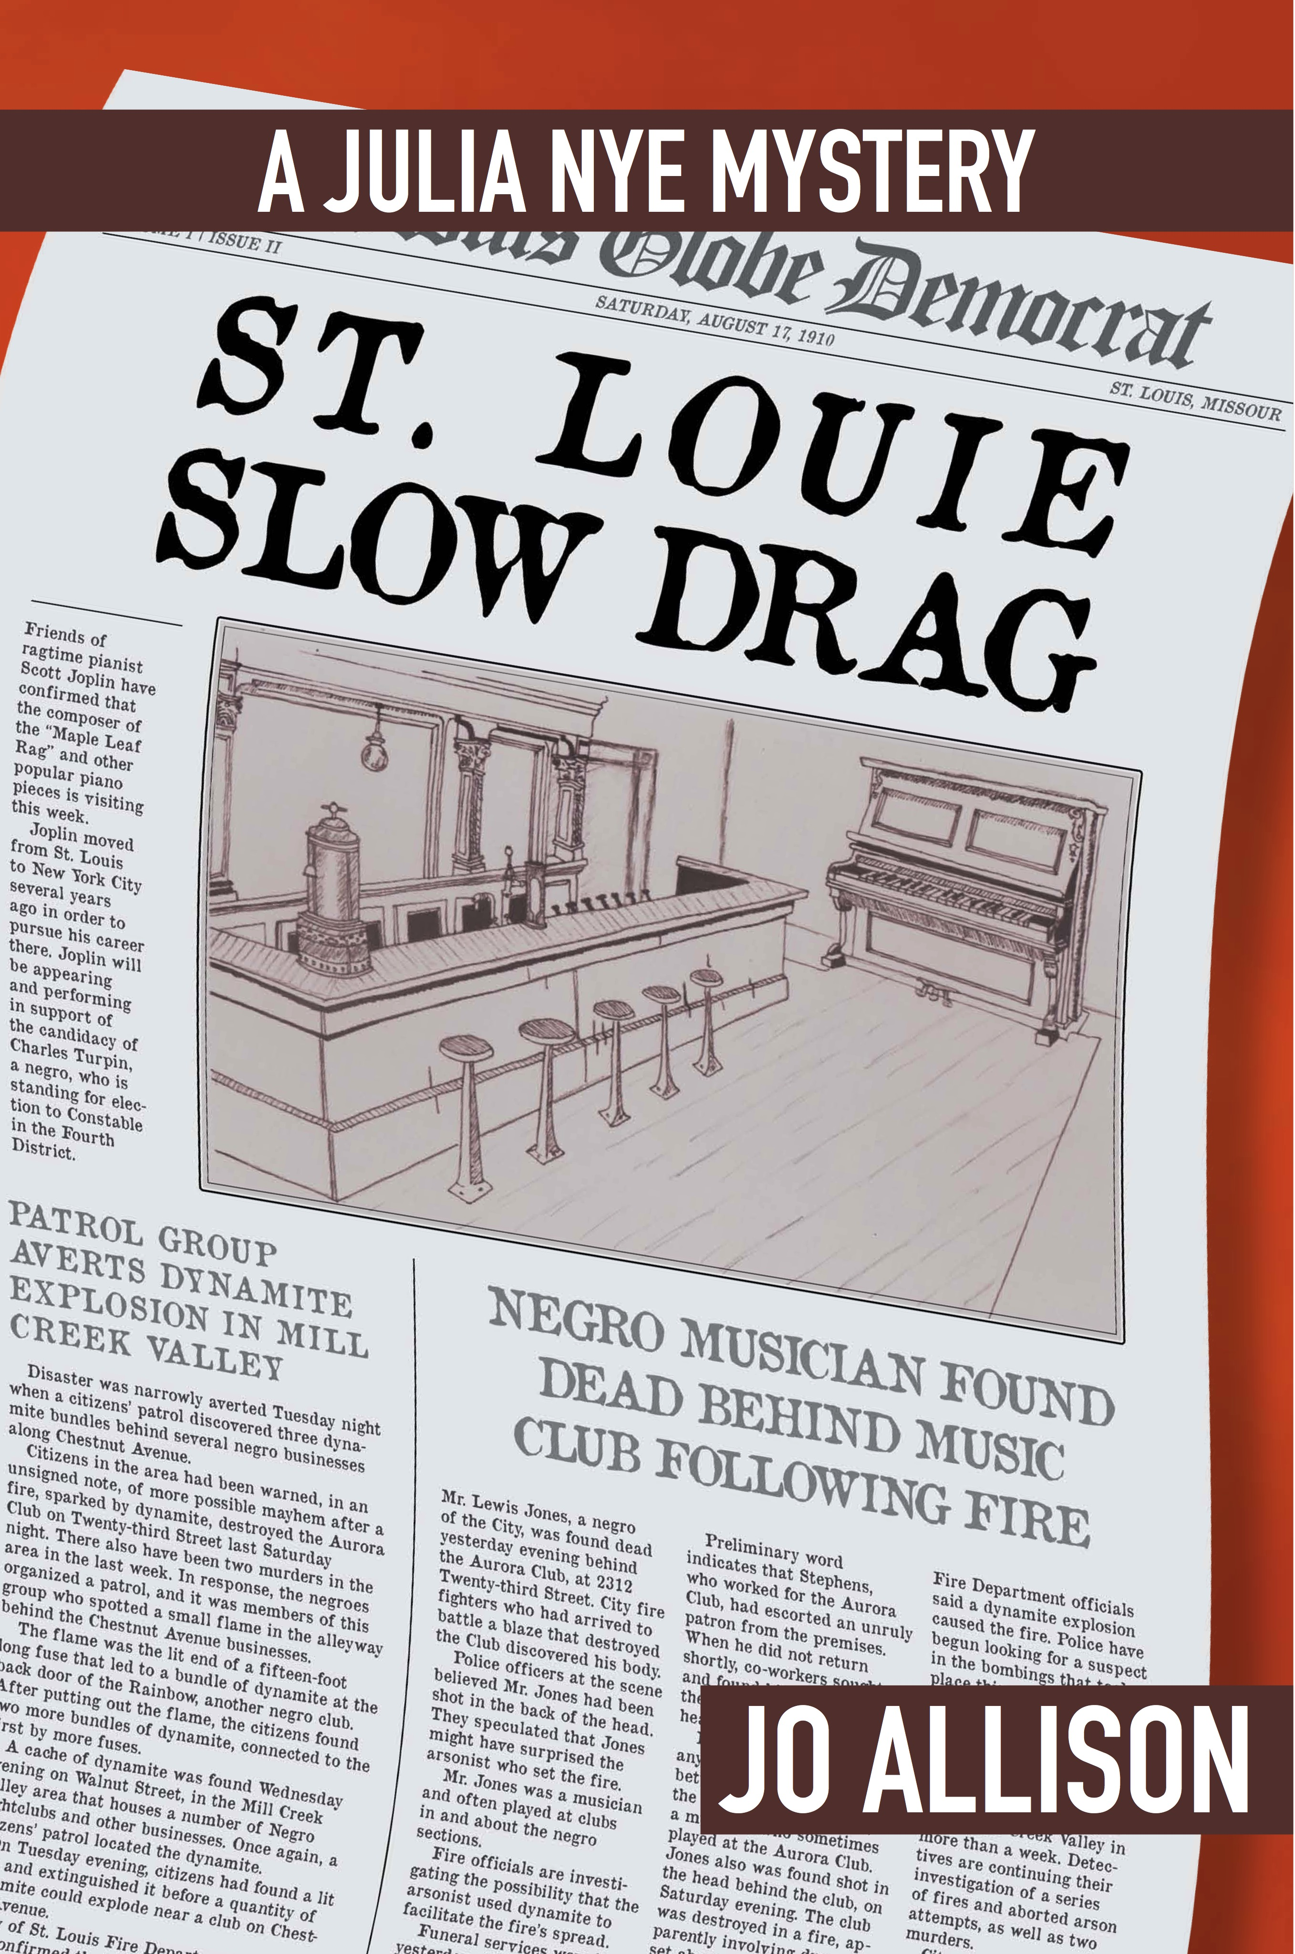
Expanded Contact Information and Web Presence

Email: lhdobkins@gmail.com

Websites: joallisonauthor.com for information about Jo Allison and the series and related short stories.
oldunderwoodpublish.com for information more specifically on the books in the series, published and forthcoming, with links to Amazon buying pages.
1910-stlouis-by-jallison.com for a detailed micro-history of 1910 in general and 1910s St. Louis in particular.

Phone: 540-239-6221

Address: Jo Allison
115 Timberbrook Dr.
Bristol, VA 24201

Review copies available on request.

